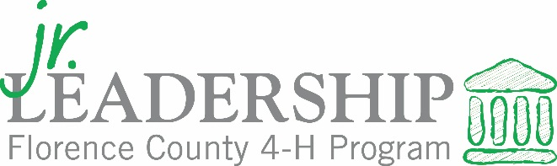
Brought to you by Clemson Extension, The Greater Florence Chamber of Commerce & Francis Marion University
Dear Applicant:
Congratulations on your decision to apply for the prestigious 2020-21 Junior Leadership Florence County Program! A maximum of 26 current high school freshman and sophomores from across Florence County will be selected to participate in this nine-month program during their sophomore or junior year.
Before beginning the application, please read the following information carefully and make sure that you do not have any conflicts with the dates listed. All applicants should confirm with a parent/guardian and school official before applying. The cost of the program is a $75 commitment fee. If selected, the $75 fee will be due by July 15 and can be broken up into 3 payments.
Eligibility:
- Students must be classified as high school sophomores or juniors during the 2020-21 school year.
- The program is open to public, private and home schooled students who live and/or attend school in Florence County.
- Students must be in good academic standing with their school and must have a written endorsement from their high school principal or guidance counselor as well as support of their parent/guardian.
Student Commitments:
- Both students and parents must review orientation information and sign a memorandum of understanding.
- Attend the mandatory opening retreat in August.
- Only 1 excused absences will be allowed during the program monthly sessions. In order to graduate, all participants must attend at least 7 out of the 8 monthly sessions.
- Students are expected to abide by the Code of Conduct during each session/activity/event.
- Each member must complete a minimum of 4 community service hours during the program year and report to the program coordinator. (This will require time outside of the scheduled JLFC program dates.)
- Applicants must have transportation to and from sessions noting that sessions will take place across the county.

Application Requirements:
- Fill out the application and supporting forms completely and return to the following no later than March 15: Junior Leadership Florence County Selection Committee
c/o Clemson Extension Service – Florence County
2685 S Irby Street, Suite K, Florence 29505
OR scan & e-mail to flawrim@clemson.edu
Selection Process:
- All written applications will be reviewed by professionals from out of the Florence County area and the highest scoring written applicants will be asked to attend a 3-person interview. Members of the JLFC Advisory Board and local business leaders will serve as the interview panelists. Rubrics for both the written application and interviews are attached.
- JLFC is committed to cultural and economic diversity and considers all students who have demonstrated leadership skills and talents.
- All applicants will be notified of the status of their application no later than May 31.
Good luck with your application, and please do not hesitate to contact me if you have any questions at 843-519-2406 or email flawrim@clemson.edu.
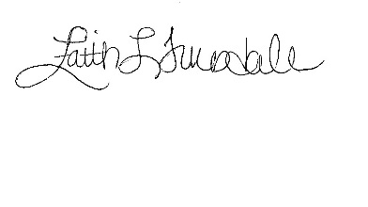
Warmest regards,

Faith Truesdale
Florence County 4-H & Youth Development Agent

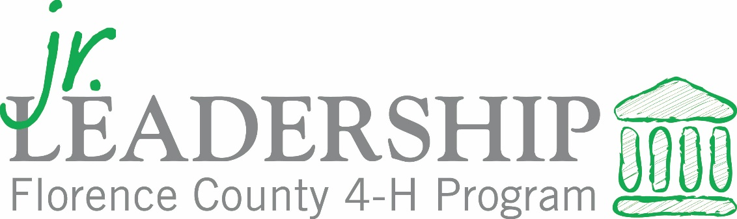
The written application is worth a total of 50 points. Below is the rubric for the written applications:

Organization & Activity Score  ______ out of 15 | Short Answer Score  _____ out of 25 | Overall Spelling/Grammar/Speech  _______ out of 10

The highest scoring written applicants from each school are invited to take part in a group interview. Three to four candidates will be interviewed each time slot with students rotating the order in which questions are answered out of fairness to all. Students should be prepared to answer normal job interview style questions. The interview is also worth 50 points and the rubric is below:

First Impression  (arrives on time,  dressed professionally,  appropriate greeting, etc.) | ______ out of 10 maximum points
General Attitude/  Personality/Enthusiasm | ______ out of 10 maximum points
Preparedness  (understands the time commitments, responsibility of the program, etc.) | ______ out of 10 maximum points
Communication & Ability to respond to questions  (speaks clearly and professionally,  listens attentively, engaging, originality, etc.) | ______ out of 20 maximum points

